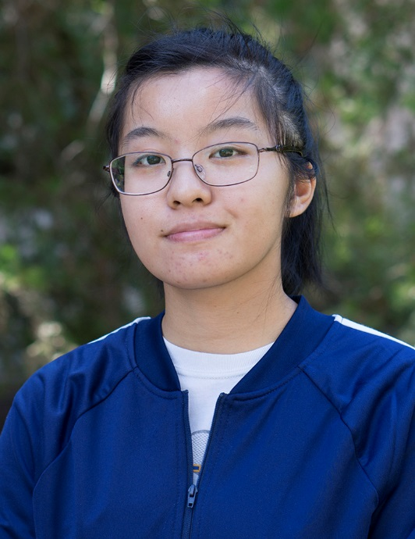

Victoria Vu
Winter 2018

Computer Room Consultant
of the Quarter
Shields

 | Chris Gerken  Fall 2017 |  | Leslie Quintanilla  Spring 2017 |  | Chris Gerken  Winter 2017
 | Yeleng Thao  Fall 2016 |  | Jaimie Guzman  Spring 2016 |  | Kendra Forst  Winter 2016
 | Khoa Truong  Fall 2015 | 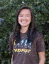 | Ashley Wong  Spring 2015 |  | Emily Bushman  Winter 2015

Computer Lab Management
IET-Academic Technology Services

